**Requirement Gathering and Analysis Phase**

**Data Flow Diagram & User Stories**

|  |  |
| --- | --- |
| Date | 05/07/2024 |
| Team ID | SWTID1720014974 |
| Project Name | Book-Store |
| Maximum Marks | 3 |

**Data Flow Diagram:**

1. **User:**

* Interacts with the system to browse, search, and purchase books.
* Can also sell books.

1. **Order:**

* Collects order information from the user (book selection, quantity, format - hardcopy or softcopy).
* Sends order details to the "Process Order" component.

1. **Process Order:**

* Takes order information and user details.
* Sends order and user details to the "Invoices" component.

1. **Invoices:**

* Generates billing information based on the order.
* Sends billing information to the "Collect Payment" component.
* Determines the type of book (hardcopy or softcopy) and sends the appropriate information to either "Ship Products" or "E-Delivery".

1. **Collect Payment:**

* Receives billing information and user details.
* Processes payment.
* Sends payment confirmation and any related invoices or statements to the user.

1. **Ship Products:**

* Receives shipping information from the "Process Order" component.
* Sends shipping information to the "Fulfilment" component.
* Ensures product delivery to the user if it's a hardcopy.

1. **E-Delivery:**

* Provides download link or e-copy for softcopy orders.

1. **Fulfilment:**

* Handles the fulfilment of orders.

1. **Sell Books:**

* Users can list their books for sale.
* After verification , payments are processed to user and books are collected.

**Diagram:**

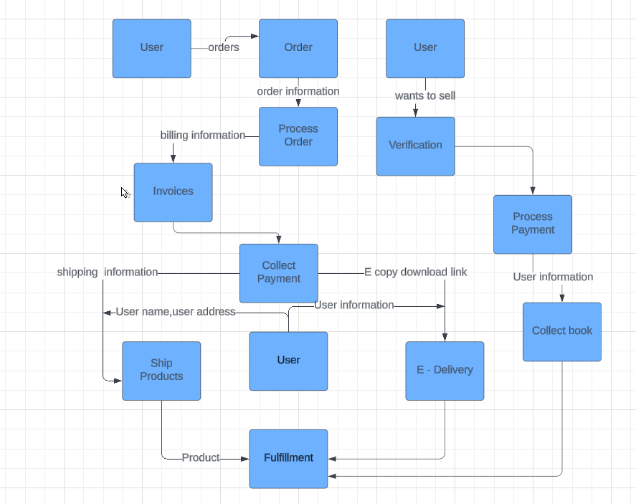

**User Stories:**

| **User Type** | **Functional Requirement (Epic)** | **User Story Number** | **User Story / Task** | **Acceptance criteria** | **Priority** | **Release** |
| --- | --- | --- | --- | --- | --- | --- |
| Customer (Web user) | Registration | USN-1 | As a user, I can register for the application by entering my email, password, and confirming my password. | I can access my account / dashboard | High | Sprint -1 |
|  |  | USN-2 | As a user, I will receive confirmation email once I have registered for the application | I can receive confirmation email & click confirm | High | Sprint-1 |
|  | Login | USN-3 | As a user, I can log into the application by entering email & password | I can access my account/dashboard | High | Sprint-1 |
|  | Dashboard | USN-4 | As a user , As a user, I want to access and view my personal dashboard so that I can manage my profile. | I can access and view my dashboard, which includes my profile, purchase history, wishlist, current orders,book swap/rent requests, selling dashboard, messages, reviews and ratings, payment methods, account settings. | High | Sprint- 2 |
| Customer (Mobile user) | Registration | USN-5 | As a user, I can register for the application by entering my email (or gmail), password, and confirming my password (or) by entering mobile number | I can access my account / dashboard | High | Sprint -1 |
|  |  | USN-6 | As a user, I will receive confirmation email (or) OTP once I have registered for the application | I can receive confirmation email (or) OTP & click confirm | High | Sprint- 1 |
|  | Login / Dashboard | USN-7 | As a user, I can log into the application by entering email & password and access my personal dashboard | I can access my account/dashboard | High | Sprint- 2 |
| Customer Care Executive | Access User Queries | USN-8 | As a customer care executive, I want to access and respond to user queries and support requests,so that I can provide timely assistance and resolve issues. | I can log into the customer care portal and I am able to view and respond to user queries and support requests. | High | Sprint- 2 |
|  | Order Management | USN-9 | As a customer care executive,  I want to view and manage user orders,  so that I can help users with order tracking, returns, and cancellations. | I can access the order management section, where I am able to view order details, track statuses, and process returns or cancellations. | High | Sprint-2 |
|  | Communication Tool | USN-10 | As a customer care executive, I must be able to communicate with users who faces problems in the application | I am able to communicate with the help of email , SMS | Medium | Sprint-3 |
| Administrator | User Management | USN-11 | As an app administrator,I want to manage user accounts,so that I can ensure accurate and up-to-date user information on the platform. | I can access the user management section, and I am able to create, update, and delete user accounts. | High | Sprint-3 |
|  | Platform Management | USN-12 | As an app administrator,I want to access analytics and reporting tools,so that I can monitor platform performance and user activity. | I can access the analytics and reporting tools, **and I am** able to view platform performance metrics, user activity data, and sales reports. | High | Sprint-3 |